SPARK: Simple Play Adaptations to Reference for Kids

Matching Picture Lotto BINGO Built-in Switch Game
Description: | Image:
Game board is mounted on an electronic base with nine red LED’s that light up when players match the right picture word cards to the right word and picture on the game board. Activate the yellow button to scan the board for the right match; release it to select the match. Activate the blue button to correct mistakes and restart the game. Two jacks on the side of the toy allow users to play using their own switches (e.g. Buddy Buttons available for loan). Four reversible playing cards are included. | 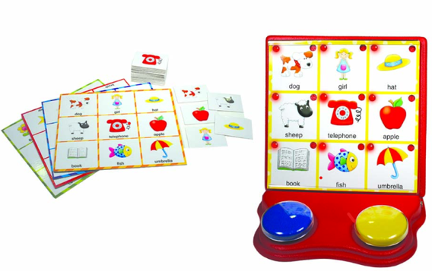  Purchasing Information  User’s Manual

Who Might Benefit?
Those who…
• Benefit from simple cause and effect activities in which the child does something (activates a switch) and the game board lights up.
• Need to further develop reaching, targeting, and eye hand coordination.
• Need engaging visual and auditory materials to support attention to activity.
• Have fine motor challenges and are unable to engage in typical board game activities (rolling dice, picking up or moving game tokens, etc.).
• Have limited mobility to ability to assume varied play positions.
• Are learning to match pictures to pictures, pictures to words, etc.
• Need more opportunities to interact with peers.

Why Use?
Provides an opportunity to…
• Develop experience using simple switches.
• Practice hand-eye coordination and problem solving.
• Participate in an engaging activity with multi-sensory supports (bright colors, lights, switch-activated scanner, etc.).
• Learn switch scanning which is useful for other activities including use of certain voice output devices, computer programs, and apps.
• Practice identifying words and pictures.
• Engage in cooperative play behaviors such as turn taking.
Instructions for Use: | Adaptation Ideas:
Environmental Considerations  A flat surface (tabletop or floor) is needed with enough space for the adapted game board, spinner, playing boards for additional players, and any additional switches.  - Use in any environment including community, home, and school. The product does have lights and sounds which may be disruptive in quiet environments.  Positioning  This game can be set up to allow access to users with multiple positional needs.  Children should be positioned (sitting at a table, sitting on the floor, or lying on their tummy on the floor) along with peer players so that they can view the game boards and reach the adapted game board switches.  Basic Play/Use  Each player gets a playing board with 9 pictures.  A teacher or player takes turns picking playing cards from a deck.  - To take a turn, place the drawn picture card in the holding slot on the front of the game board base.  - Encourage the child to push the yellow 2-1/2" button to scan the board for the right match.  - Point to the pictures as they are scanned using verbal prompts to teach the scanning process (ex. “Look! Does it match?”)  - The blue button is pushed to clear the board or correct mistakes.  - When the child has selected the picture that matches the picture card, they need to lift their hand off the switch and the light will lock in place.  - The game is won when all 9 lights are locked in place (or for the children playing with cardboard game boards and matching cards). At that point all the lights on the adapted game board will flash and music will play.  Extended Play/Use  Match the word on the back of the picture (with its word beneath) on the playing board.  Match the word only on the back of the picture card to the word on the back of the playing board.  Match the picture only cards to the words on the back of the playing board.  Bingo-An adult or older child will select the playing cards and read them out loud. As the card is read, the player with the matching on their playing board claims it.  - An adult could draw a card and ask a “wh” question about it and the children match it to a picture on their board. As the children become familiar with the game, they could take turns asking the questions.  - Take photos of the games in the Built-In Switch Adapted Game Kit and print the photos. Create a foam board choice board and encourage the child to select which game they would like to play. When the child selects, honor their choice by providing the selected game. Begin by providing 2 choices adding additional choices as the child tolerates.  Play/Use with Others  - Consider giving each child a turn using the adapted game board.  - Develop social scripts as necessary to teach turn taking.  - Model and teach turn taking with a “Your turn” card or by saying “your turn”.  - Teach sportsmanship using words like “good game”. | Optional Additional Materials/Supplies  - Velcro  - Dycem or shelf liner  - Carpet square  - Textured fabric  Build It Up  - Enlarge switch surface with foam board.  Stabilize It  - Velcro bottom of switch and/or game board to carpet, or use Dycem or shelf liner, to keep games and switches from shifting out of reach  - For children using the typical playing boards, very small pieces of Velcro could be placed on both the playing boards and the Lotto cards so that they remain in place if jostled.  - If the child is having difficulty controlling their reach to the game board switches, encourage the child to rest their forearm on the table while engaged in the activity which requires less control than using the entire arm.  Simplify It  - Cover rows not being scanned to reduce the number of cards the child must look at and choose from.  - Choose draw cards for 2 rows instead of 3 and cover the remaining row.  - Cover a whole column so the child only needs to scan 2 choices horizontally if they have difficulty visually tracking.  - Use a fly swatter with center cut out to “frame” the choices one at a time.  Add Sensory Cues  - Apply various textures to switch surfaces to add tactile interest  Communication Support  - Use “Wait”, “My turn”, “Your turn”, “First/Then” cards.  Alternative Uses  - Adapt this game for shape, letter, or number recognition by creating additional game cards matching the size of the original ones. For the game cards used with the adapted game board, cut a hole so the light will be displayed when the game card is scanned.  - Different types of switches could be trialed if the included switch is not usable by the child. The OCALI lending library has several kits with multiple types of switches that can be trialed.  DIY Alternatives  - What Doing LOTTO BINGO free download It’s a matching game with typically 6 images to a sheet, with a corresponding sheet of 6 words. For younger readers, choose 4 images to a sheet. In the beginning, cover half the sheet to expose just 3 images, or cover one third of the sheet to expose just 4 images.

Additional Considerations:
- 2 AA batteries are required to be installed in the game board to work properly.
- Use “Wait”, “My turn” “Your turn” “First/Then cards.
- Point with finger to help child track the lighted selection choices.
- Use the verbal directions such as “find yellow button”, “find blue button”, “push”, “let go”, “up”, “down”, “next”, “back”, “over”, “right”, and “left” to help child locate the yellow button to start scan, release the yellow button to select picture, or locate the blue button to correct the selection.

Resources:
- Create a Choice Board - The OCALI Autism Center Grab and Go Resource Gallery of Interventions has a number of choice board templates and examples that could be used to create the choice boards indicated above in the Extended Play/Use section. Additionally, there are several examples of different ways choice boards can be effectively displayed.

Ohio Early Learning Standards:
- LL: Language and Communication. Develops and expands understanding of vocabulary and concepts. Connects words with objects (1.b.).
- SC: Science Inquiry and Application: Develops ability to reason about cause and effect. (1.b.).

Words to Encourage Play/Use
Look  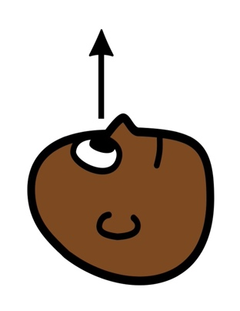 | Find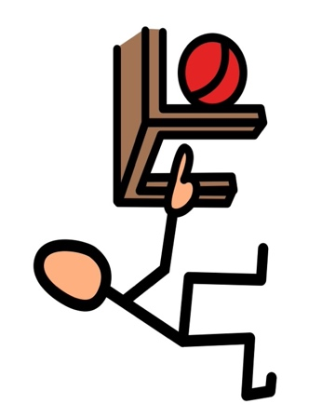 | Push
Stop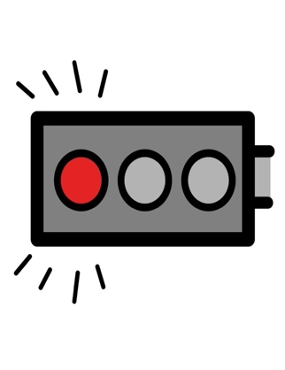 | Go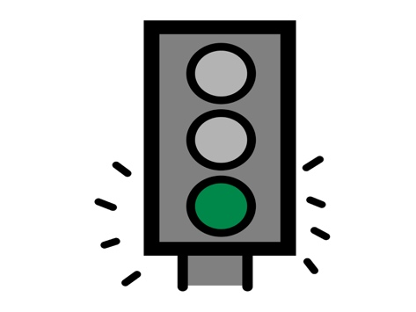 | Same  
Your turn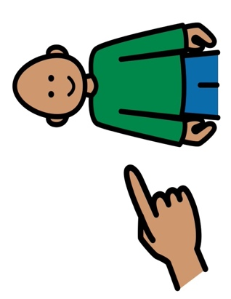 | My turn  | Wait  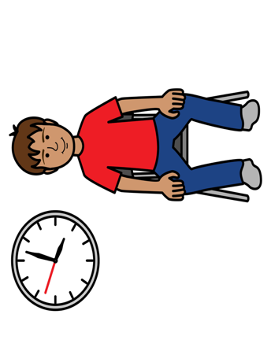
*”Adaptations” adapted from: Haugen’s Modes for Adapting Toys based on materials from the "Let's Play" Project at the University of Buffalo
PCS is a trademark of Tobii Dynavox, LLC. All rights reserved. Used with permission.

